**ProjectDesignPhase-II**

**DataFlowDiagram&UserStories**

|  |  |
| --- | --- |
| Date | 14October2022 |
| TeamID | PNT2022TMID17177 |
| ProjectName | Project -xxx |
| MaximumMarks | 4Marks |

**DataFlowDiagrams:**

ADataFlowDiagram(DFD)isatraditionalvisualrepresentationoftheinformationflowswithinasystem.AneatandclearDFDcandepicttherightamount of the system requirement graphically. It shows how data enters and leaves the system, what changes the information, and where data isstored.

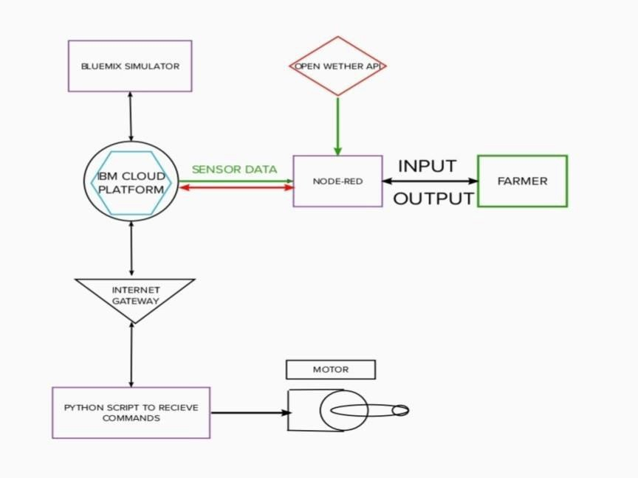

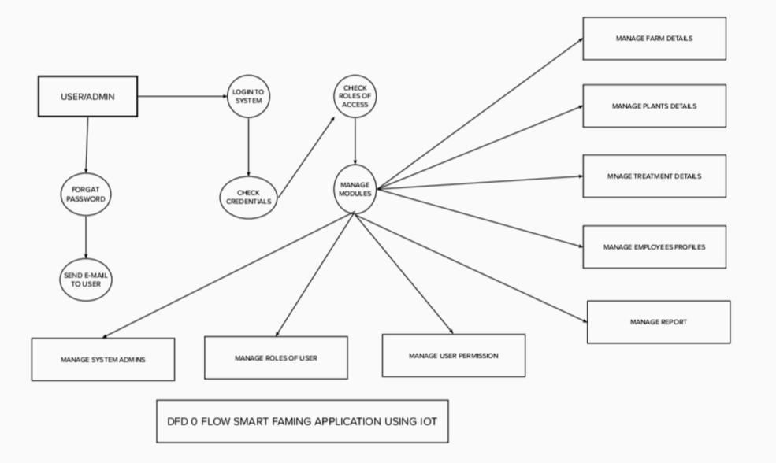

* *The different soil parameters temperature, soil moistures and then humidity are sensed usingdifferentsensorsandobtainedvalueisstoredintheibmcloud.*
* *Aurdino UNO is used as a processing Unit that process the data obtained from the sensors andwhetherdatafromtheweatherAPI.*
* *NODE-RED is used as a programming tool to write the hardware, software and APIs. The MQTTprotocolisfollowedforthecommunication.*
* *All the collected data are provided to the user through a mobile application that was developedusingtheMITappinventor.Theusercouldmakeadecisionthroughanapp,weathertowaterthecropornotdependinguponthesensorvalues.Byusingtheapptheycanremotelyoperatetothemotorswitch.*

**UserStories**

Usethebelowtemplatetolistalltheuserstoriesfortheproduct.

|  |  |  |  |  |  |  |
| --- | --- | --- | --- | --- | --- | --- |
| **UserType** | **FunctionalRequirement**  **(Epic)** | **User StoryNumber** | **UserStory/Task** | **Acceptancecriteria** | **Priority** | **Release** |
| Customer(Mobileuser) | Registration | USN-1 | Asauser,Icanregisterfortheapplicationby  entering my email, password, and confirmingmypassword. | Icanaccessmyaccount/dashboard | High | Sprint-1 |
|  |  | USN-2 | Asauser,IwillreceiveconfirmationemailonceIhaveregisteredfortheapplication | Icanreceiveconfirmationemail&click confirm | High | Sprint-1 |
|  |  | USN-3 | Asauser,IcanregisterfortheapplicationthroughFacebook | Icanregister&accessthedashboard with  FacebookLogin | Low | Sprint-2 |
|  |  | USN-4 | Asauser,IcanregisterfortheapplicationthroughGmail |  | Medium | Sprint-1 |
|  | Login | USN-5 | Asauser,Icanlogintotheapplicationby  enteringemail&password |  | High | Sprint-1 |
|  | Dashboard |  |  |  |  |  |
| Customer (Webuser) |  |  |  |  |  |  |
| CustomerCare  Executive |  |  |  |  |  |  |
| Administrator |  |  |  |  |  |  |
|  |  |  |  |  |  |  |
|  |  |  |  |  |  |  |
|  |  |  |  |  |  |  |